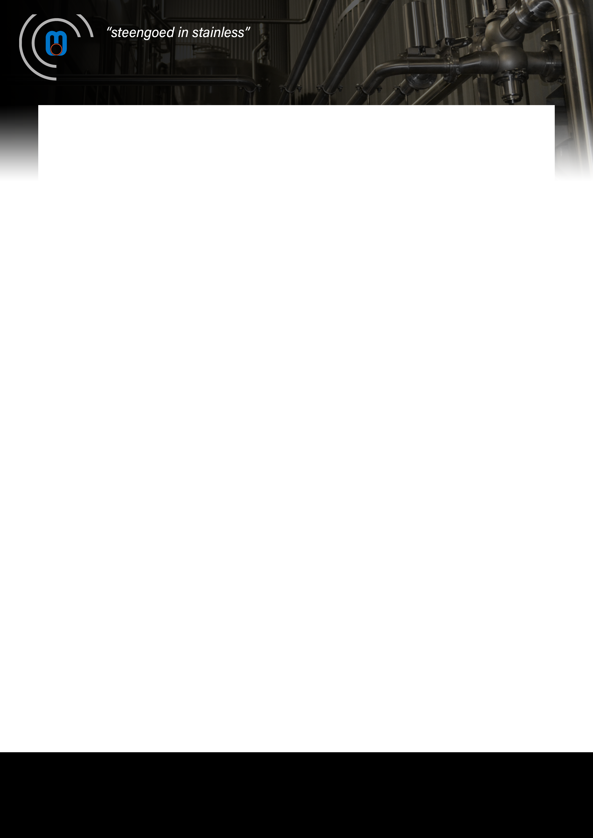

M.S. Stainless International Group
2-3, Reimerwee
L-9681 ROULINGEN (WILTZ)
Tel. +352 950909
Email Luxembourg@msstainless.com
Website www.msstainless.com
We would like to draw your attention to the Pressureless manhole cover.

M.S. STAINLESS LUXEMBOURG S.A.

